***Superior University Lahore***

***Gold Campus***

***Department Of Information & Technology***

***Mobile Application and Development***

***Assignment: 02***

***Name*:**

**Abdul Basit** (Bitm-F19-046)

**Section:**

BSIT 6A

**Submitted To:**

Sir Javaid Iqbal

**Code of Home.XML**

<?xml version="1.0" encoding="utf-8"?>  
<androidx.constraintlayout.widget.ConstraintLayout xmlns:android="http://schemas.android.com/apk/res/android"  
 xmlns:app="http://schemas.android.com/apk/res-auto"  
 xmlns:tools="http://schemas.android.com/tools"  
 android:layout_width="match_parent"  
 android:layout_height="match_parent"  
 android:background="@drawable/kfc"  
 tools:context=".MainActivity">  
  
 <TextView  
 android:layout_width="wrap_content"  
 android:layout_height="wrap_content"  
 android:text="WELCOME TO"  
 android:textColor="@android:color/white"  
 android:textSize="40dp"  
 android:typeface="sans"  
 app:layout_constraintBottom_toTopOf="@+id/textView"  
 app:layout_constraintEnd_toEndOf="parent"  
 app:layout_constraintStart_toStartOf="parent" />  
  
 <TextView  
 android:id="@+id/textView"  
 android:layout_width="wrap_content"  
 android:layout_height="wrap_content"  
 android:layout_marginTop="160dp"  
 android:text="KFC"  
 android:textColor="@android:color/white"  
 android:textSize="60dp"  
 android:typeface="sans"  
 app:layout_constraintEnd_toEndOf="parent"  
 app:layout_constraintStart_toStartOf="parent"  
 app:layout_constraintTop_toTopOf="parent"></TextView>  
  
  
 <LinearLayout  
 android:layout_width="match_parent"  
 android:layout_height="wrap_content"  
 android:layout_marginTop="50dp"  
 android:orientation="horizontal"  
 android:padding="5dp"></LinearLayout>  
  
 <ImageView  
 android:layout_width="166dp"  
 android:layout_height="185dp"  
 android:layout_marginTop="64dp"  
 android:src="@drawable/babakfc"  
 app:layout_constraintEnd_toEndOf="parent"  
 app:layout_constraintHorizontal_bias="0.497"  
 app:layout_constraintStart_toStartOf="parent"  
 app:layout_constraintTop_toBottomOf="@+id/textView" >  
 </ImageView>  
  
 <Button  
  
 android:id="@+id/button"  
 android:layout_width="wrap_content"  
 android:layout_height="wrap_content"  
 android:text="Click To Continue"  
 android:textColor="@android:color/white"  
 android:textSize="20dp"  
 tools:layout_editor_absoluteX="80dp"  
 tools:layout_editor_absoluteY="519dp" />  
  
  
</androidx.constraintlayout.widget.ConstraintLayout>

**Screen shot of Home.XML**

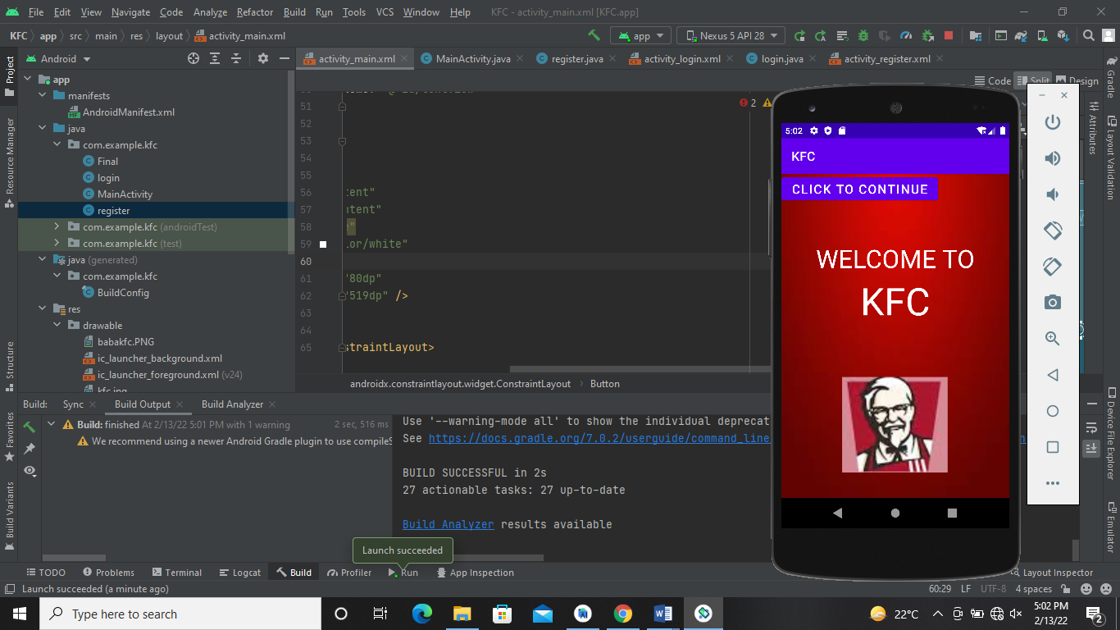

**Code of Login.XML**

<?xml version="1.0" encoding="utf-8"?>  
<androidx.constraintlayout.widget.ConstraintLayout xmlns:android="http://schemas.android.com/apk/res/android"  
 xmlns:app="http://schemas.android.com/apk/res-auto"  
 xmlns:tools="http://schemas.android.com/tools"  
 android:layout_width="match_parent"  
 android:layout_height="match_parent"  
 android:background="@drawable/kfc"  
 tools:context=".MainActivity">  
  
 <TextView  
 android:id="@+id/textView"  
 android:layout_width="wrap_content"  
 android:layout_height="wrap_content"  
 android:layout_marginTop="136dp"  
 android:text="KFC"  
 android:textColor="@android:color/white"  
 android:textSize="25dp"  
 android:typeface="sans"  
 app:layout_constraintEnd_toEndOf="parent"  
 app:layout_constraintStart_toStartOf="parent"  
 app:layout_constraintTop_toTopOf="parent">  
  
 </TextView>  
  
 <LinearLayout  
 android:layout_width="380dp"  
 android:layout_height="wrap_content"  
  
 android:background="@android:color/white"  
 android:orientation="vertical"  
 android:padding="30dp"  
 app:layout_constraintBottom_toBottomOf="parent"  
 app:layout_constraintEnd_toEndOf="parent"  
 app:layout_constraintHorizontal_bias="0.516"  
 app:layout_constraintStart_toStartOf="parent"  
 app:layout_constraintTop_toBottomOf="@+id/textView"  
 app:layout_constraintVertical_bias="0.32">  
  
  
 <LinearLayout  
 android:layout_width="match_parent"  
 android:layout_height="wrap_content"  
 android:layout_marginTop="50dp"  
 android:orientation="horizontal"  
 android:padding="5dp">  
  
 <ImageView  
 android:layout_width="30dp"  
 android:layout_height="match_parent"  
 android:src="@drawable/user2"></ImageView>  
  
 <EditText  
 android:layout_width="match_parent"  
 android:layout_height="wrap_content"  
 android:backgroundTint="#00000000"  
 android:hint="USER NAME"  
 android:textColor="@android:color/black"  
 android:textColorHint="@android:color/black"></EditText>  
  
  
 </LinearLayout>  
  
 <androidx.appcompat.widget.SwitchCompat  
 android:layout_width="wrap_content"  
 android:layout_height="wrap_content"  
 android:layout_gravity="right"  
 android:padding="5dp">  
  
 </androidx.appcompat.widget.SwitchCompat>  
  
  
 <LinearLayout  
 android:layout_width="match_parent"  
 android:layout_height="wrap_content"  
 android:orientation="horizontal"  
 android:padding="5dp">  
  
 <ImageView  
 android:layout_width="30dp"  
 android:layout_height="match_parent"  
 android:src="@drawable/lock">  
  
 </ImageView>  
  
 <EditText  
 android:layout_width="match_parent"  
 android:layout_height="wrap_content"  
 android:backgroundTint="#00000000"  
 android:hint="PASSWORD"  
 android:textColor="@android:color/black"  
 android:textColorHint="@android:color/black"></EditText>  
 </LinearLayout>  
  
 <TextView  
 android:layout_width="wrap_content"  
 android:layout_height="wrap_content"  
 android:layout_gravity="right"  
 android:padding="5dp"  
 android:text="Forgot Password?"  
 android:textSize="15dp"></TextView>  
  
 <Button  
 android:id="@+id/button"  
 android:layout_width="match_parent"  
 android:layout_height="wrap_content"  
 android:text="Login"  
 android:textColor="@android:color/white"></Button>  
  
  
 </LinearLayout>  
  
 <ImageView  
 android:id="@+id/imageView"  
 android:layout_width="90dp"  
 android:layout_height="90dp"  
 android:src="@drawable/babakfc"  
 app:layout_constraintEnd_toEndOf="parent"  
 app:layout_constraintStart_toStartOf="parent"  
 app:layout_constraintTop_toBottomOf="@+id/textView">  
  
 </ImageView>  
  
  
</androidx.constraintlayout.widget.ConstraintLayout>

**Screen shot of Login.XML**

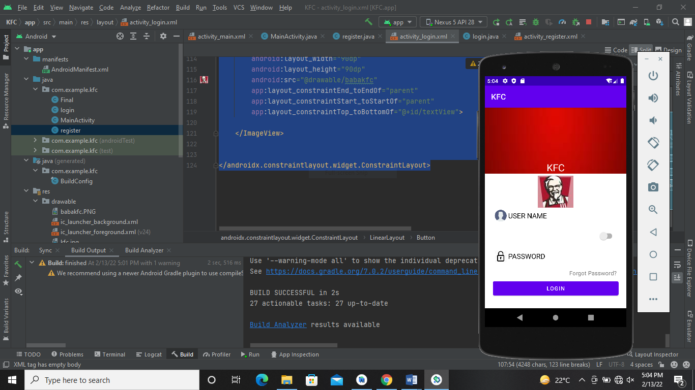

**Code of Register.XML**

<?xml version="1.0" encoding="utf-8"?>  
<androidx.constraintlayout.widget.ConstraintLayout xmlns:android="http://schemas.android.com/apk/res/android"  
 xmlns:app="http://schemas.android.com/apk/res-auto"  
 xmlns:tools="http://schemas.android.com/tools"  
 android:layout_width="match_parent"  
 android:background="@drawable/kfc"  
 android:layout_height="match_parent"  
 tools:context=".register">  
  
 <TextView  
  
 android:id="@+id/textView"  
 android:layout_width="wrap_content"  
 android:layout_height="wrap_content"  
 android:layout_marginTop="136dp"  
 android:text="KFC"  
 android:textColor="@android:color/white"  
 android:textSize="25dp"  
 android:typeface="sans"  
 app:layout_constraintEnd_toEndOf="parent"  
 app:layout_constraintStart_toStartOf="parent"  
 app:layout_constraintTop_toTopOf="parent">  
  
 </TextView>  
  
 <LinearLayout  
 android:layout_width="380dp"  
 android:layout_height="wrap_content"  
  
 android:background="@android:color/white"  
 android:orientation="vertical"  
 android:padding="30dp"  
 app:layout_constraintBottom_toBottomOf="parent"  
 app:layout_constraintEnd_toEndOf="parent"  
 app:layout_constraintHorizontal_bias="0.516"  
 app:layout_constraintStart_toStartOf="parent"  
 app:layout_constraintTop_toBottomOf="@+id/textView"  
 app:layout_constraintVertical_bias="0.32">  
  
  
 <LinearLayout  
 android:layout_width="match_parent"  
 android:layout_height="wrap_content"  
 android:layout_marginTop="50dp"  
 android:orientation="horizontal"  
 android:padding="5dp">  
  
 <ImageView  
 android:layout_width="30dp"  
 android:layout_height="match_parent"  
 android:src="@drawable/user2"></ImageView>  
  
 <EditText  
 android:layout_width="match_parent"  
 android:layout_height="wrap_content"  
 android:backgroundTint="#00000000"  
 android:hint="USER NAME"  
 android:textColor="@android:color/black"  
 android:textColorHint="@android:color/black"></EditText>  
  
  
 </LinearLayout>  
  
 <androidx.appcompat.widget.SwitchCompat  
 android:layout_width="wrap_content"  
 android:layout_height="wrap_content"  
 android:layout_gravity="right"  
 android:padding="5dp">  
  
 </androidx.appcompat.widget.SwitchCompat>  
  
  
 <LinearLayout  
 android:layout_width="match_parent"  
 android:layout_height="wrap_content"  
 android:orientation="horizontal"  
 android:padding="5dp">  
  
 <ImageView  
 android:layout_width="30dp"  
 android:layout_height="match_parent"  
 android:src="@drawable/lock">  
  
 </ImageView>  
  
 <EditText  
 android:layout_width="match_parent"  
 android:layout_height="wrap_content"  
 android:backgroundTint="#00000000"  
 android:hint="PASSWORD"  
 android:textColor="@android:color/black"  
 android:textColorHint="@android:color/black"></EditText>  
 </LinearLayout>  
  
 <TextView  
 android:layout_width="wrap_content"  
 android:layout_height="wrap_content"  
 android:layout_gravity="right"  
 android:padding="5dp"  
 android:text="Forgot Password?"  
 android:textSize="15dp"></TextView>  
  
 <Button  
 android:id="@+id/button"  
 android:layout_width="match_parent"  
 android:layout_height="wrap_content"  
 android:text="Register"  
 android:textColor="@android:color/white"></Button>  
  
  
 </LinearLayout>  
  
 <ImageView  
 android:id="@+id/imageView"  
 android:layout_width="90dp"  
 android:layout_height="90dp"  
 android:src="@drawable/babakfc"  
 app:layout_constraintEnd_toEndOf="parent"  
 app:layout_constraintStart_toStartOf="parent"  
 app:layout_constraintTop_toBottomOf="@+id/textView">  
  
 </ImageView>  
  
</androidx.constraintlayout.widget.ConstraintLayout>

**Screen shot of Register.XML**

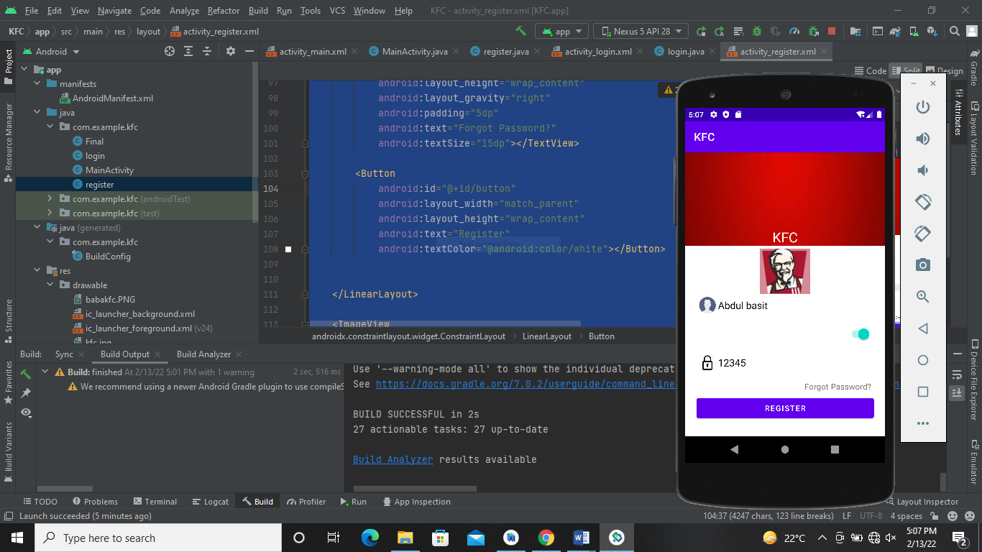

**Github Link:**

<https://github.com/AbdulBasit011/Myapp1.git>